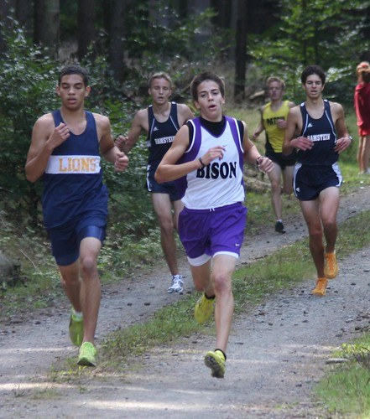
ASD-West Hatheway Middle School Sports 2020-Return to Play
ASD-West is proud to offer Middle School sports where possible for the 2020-21 school year provided that we remain in the Yellow Phase in regards to COVID-19. Middle School sports will potentially look much different as far as what we are able to offer this year. We believe it is important that we offer programs for students and schools that wish to participate.
Though Middle School sports are not governed by the NBIAA, ASD-W will be using their model in regards to implementing extracurricular sports where applicable. The NBIAA has set guidelines for return to play for High School sports with guidance from the Department of Health. This plan is based on COVID-19 Operational Plan Guide and respects Provincial protocols such as social distancing and disinfecting. This plan also follows protocols put in place by EECD with Appendix F for Physical Education and School Sports along with the Plans each Provincial Sport group has created.

ASD-W Hatheway Middle School Cross Country 2020
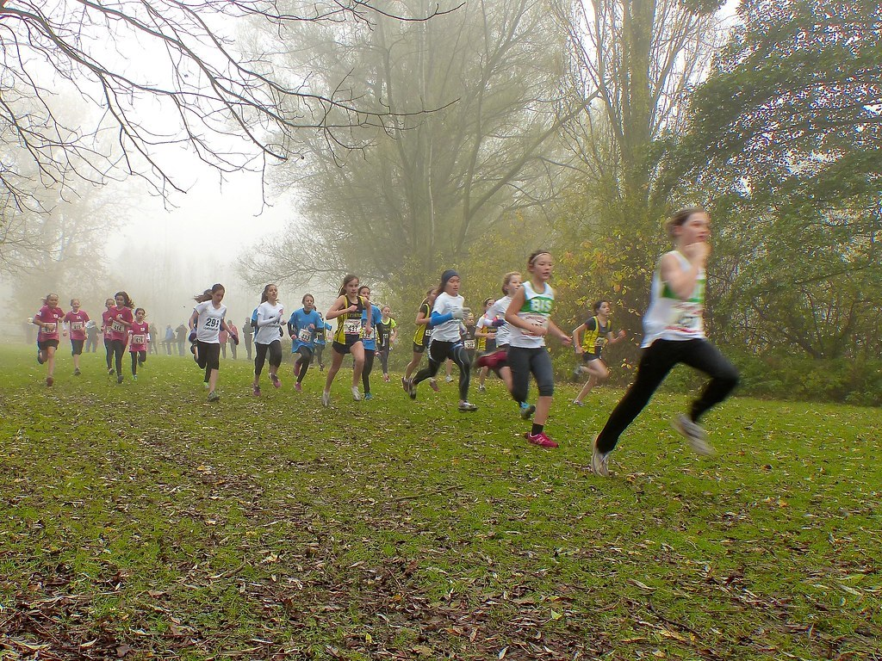
Cross country practices for Middle School can begin on Monday September 21st. 2-3 Races should occur at each individual school in each grade level and gender. Using those school-based races, each school will identify their top 3 runners per grade level per gender to compete in the district championships. The point system (same as last year) will be used to determine the top x-country school team and winner of the Banner.

Middle School Cross Country Schedule 2020 (Tentative)

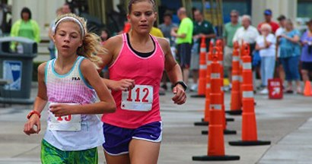
Sept 21st -Oct 16th schools will hold two- three school-based races to determine their district teams. Note that runners can only compete once every 5 days. This is outside of practice time.
Week of Oct 21st district finals will happen per grade level and gender. Schedule/Locations TBA

Cross Country Protocols

No in person registration, all registrations must be done prior to the race via email (district event)
All participants must sanitize their hands when entering the event and after the completion of their race. The host of the race will be responsible for having sanitizer present for participants.
No handing out of any awards of any type on site. All awards (including ribbons) must be sent to the school and distributed there.
Participants should come to the race area on their own just before the beginning of their race. They should also leave and return to their car immediately after they have finished their race.
Personal protective equipment should be used by all volunteers.
No high-fives, hugs, group photos or spitting.
Have any lines flow in one direction, in one way and out another.
Mark spacing for physical distancing where applicable. Ie. Create a blocked starting grid.
Ask that runners come prepared to run. There will be no access to changing facilities.

Roles and Responsibilities
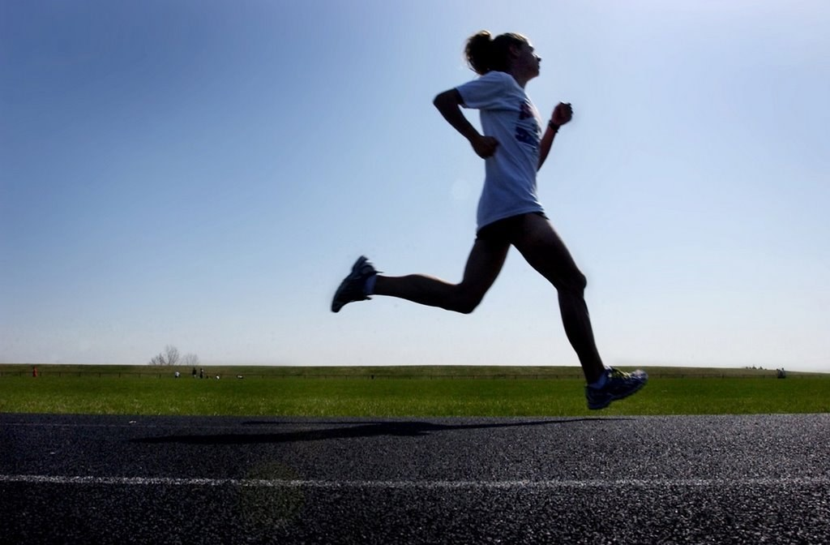
There must be a "Reception Manager" at the event to meet participants and coaches, take attendance and make sure that hands are sanitized. The name, phone number and time of everyone entering the event must be recorded and stored in a safe place for tracking purposes. For the district event students not registered cannot participate in the event. Coaches should make it known to the Reception Manager if any of their students that were registered but are not present at the event.
There should be several course volunteers on the course to keep runners on track and to remind runners of the social distancing expectation.
Course Marshal and Starter will be responsible for the start and finish of the races.
Timers will be needed for the finish as well as a Recorder.
Space should be marked off for participants to warm up in (stretching) while they wait for their start.
Ensure that equipment is disinfected prior to the race and after the races are completed.

Cross Country Race Rules
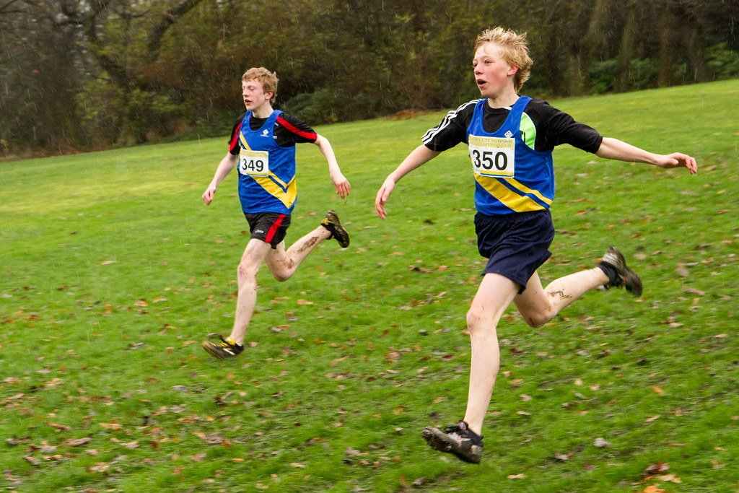
Option One: Race in timed heats of 5-6 racers at a time or as much as the start line will allow up to a max of 10 runners with a 2m social distance cube. This is to reduce on course interaction. Ensure that participants are aware of the time of their race and come for that time. It will be very important to set race times that give enough time to cycle one age/gender group out and another in. (30 minutes in between)
Option Two: Use staggered start times with a 20-30 second intervals that allow the recorder to record time minus the start interval. It will be very important to set race times that give enough time to cycle one age/gender group out and another in. (30 minutes in between)
Allow for physical distancing (2 M) in start corrals. Participants will be responsible to wear a mask upon entering the corral and until their race begins and wearing it after they finish until they leave.
No drafting permitted. Runners should verbally announce when passing someone by saying "passing". Any runner being passed should move to his or her left to let the other runner go by. A minimum of 2 M physical distance must be practiced by all participants and volunteers before, during and after the event. (Front to back and side to side; 2m cube)
The course should allow for physical distancing and must be a minimum of 2 M wide with no narrowing areas.
No two-way traffic area’s… should be a loop course.
On corners allow extra room for runners to distance.
Have volunteers on course to encourage physical distancing to runners on course and at corners. Have signage encouraging physical distancing.
Allocate more space for finish approach, line and finish chute. Finish approach should be as wide (or more) as your finish line.
Masks should be worn by participants and volunteers in the finish area.
Volunteer marshals in the finish line dispersal will remind finishers to keep moving while keeping their distance. Runners should put their mask back on once they have finished the race.
Post event gatherings of any kind should be discouraged. Ask participants to leave once they have finished their event.

Participant Reminders
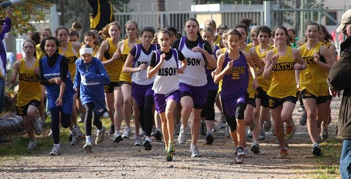
Remain 2 meters apart from others before, during and after participating in your race (no handshakes, high fives etc.). Reminder to announce when you are passing and if being passed to move to the left.
Arrive just before your race is to begin and leave immediately once your race is complete.
Avoid touching your face. Disinfect your hands before and after your race.
Do not share any food, water bottles, towels etc.
Come alone to the race start area, do not bring spectators. (Coaches can be present)

Covid-19 Symptoms
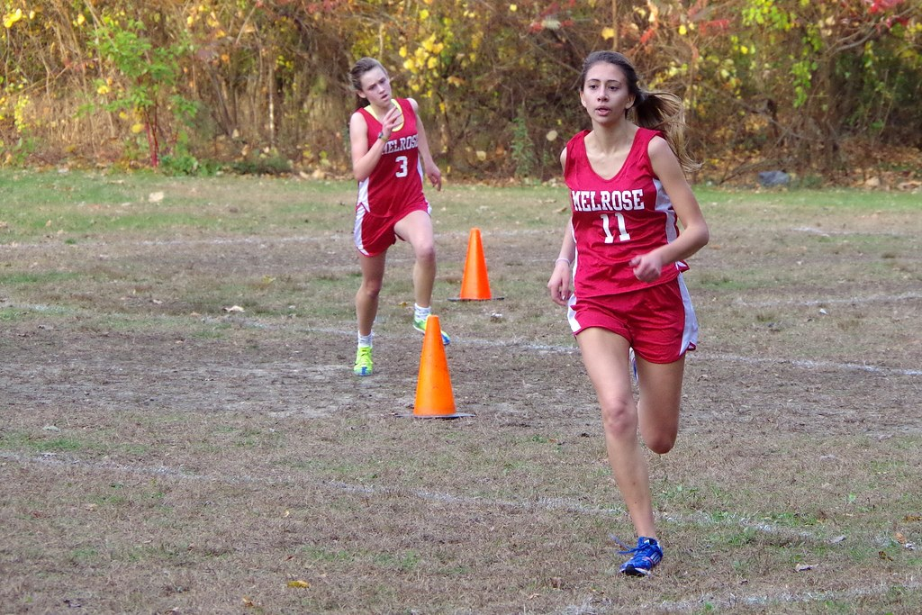
Participants should not race if they are exhibiting two or more of the following symptoms
•Fever above 38 degrees Celsius
•A new cough, or worsening chronic cough
•Sore throat
•Runny nose
•Headache
•A new onset of fatigue
•A new onset of muscle pain
•Diarrhea
•loss of sense of taste
•loss of sense of smell
•In children, purple markings on the fingers and toes
•Have been in contact with someone with COVID-19 in the last 14 days.
•Have travelled outside the province in the last 14 days
This Document was created in partnership with EECD, NBIAA, ANB and ASD-N

